**LAB 2: Modeling, Analysis, and Cross-Validation of the Dynamic**

**Responses of Geared Rotational Systems and Combined Mechanical Dynamic Systems.**

**Aim and Objectives:**

The fundamental aim of this lab is to imply the studied concepts of LAB#01 on modeling and analyzing the third (Geared Rotational Systems) as well as a fourth module (Combined Systems) of the Mechanical Dynamic Systems. Furthermore, the outcomes of the dynamic systems have been validated with the findings of SIMULINK and **ODE solvers**. Therefore, this lab is primarily dedicated to two categories of mechanical systems, and certain tangible objectives are enlightened below:

1. To model and analyze the dynamic response of Geared Dynamics as well as combined Mechanical systems (A system with the translational, rotational, and geared elements along with certain rotary to linear converters).
2. To obtain the transfer function from developed SIMSCAPE models.
3. To cross-validate the outcomes of SIMSCAPE Models with the results obtained from ODEs 45 and SIMULINK files.

**Lab Examples:**

Following are the models which were analyzed, modeled and simulated on MATLAB in the lab hours.

**Model 1:**

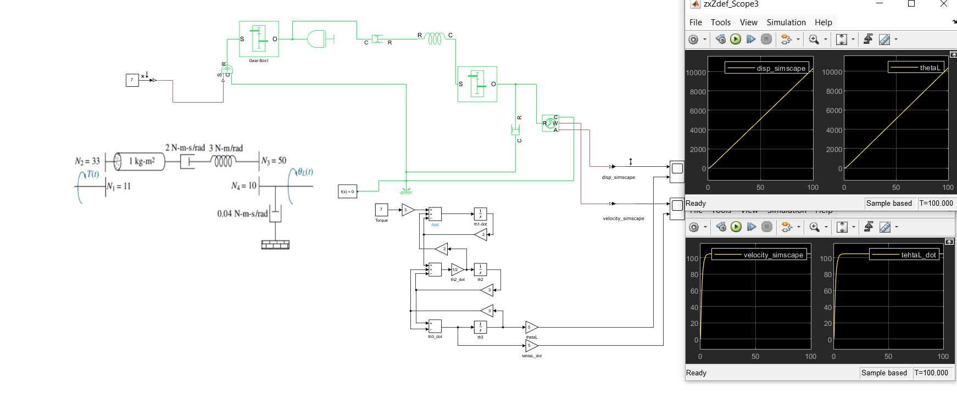

**Conclusion/Remarks:**

The results obtained by both Simulink as well as the SIMSCAPE are exactly the same. Hence the developed SIMSCAPE model is correct and is in accordance with the mathematical model (Simulink model). The graphs obtained are logical as well; the rotational output is measured across the gear which ideally rotates continuously maintaining a constant angular velocity (by the law of gearing). This phenomenon is also observed in the plots above which exhibit a linearly increasing trend for angular displacement and a constant trend for angular velocity.

**Transfer Function from SIMSCAPE model:**

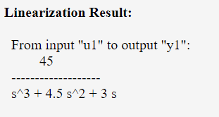

**Transfer function from m file:**

|  |
| --- |
| syms s T  A=[(s^2+2*s) , -2*s , 0 ; -2*s , (2*s+3) , -3 ; 0 , -3 , (3+s)]; B=[3*T ; 0 ; 0];  C=A\B; theta4=C(3);  thetaL=5*theta4;  G=thetaL/T;  G=collect(G,s);  [num,den]=numden(G);  num=sym2poly(num);  den=sym2poly(den);  num=num/den(1); %dividing by den(1) means dividing by the leading coefficient of denominator. Done to match the outputs  den=den/den(1);  fprintf('ThetaL(s)/T(s):')  tf(num,den) |

Following is the output:

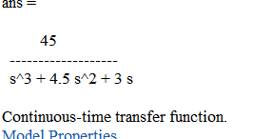

**Model 2:**

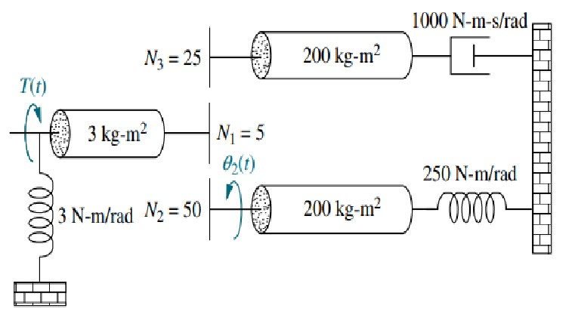

**Simulink model:**

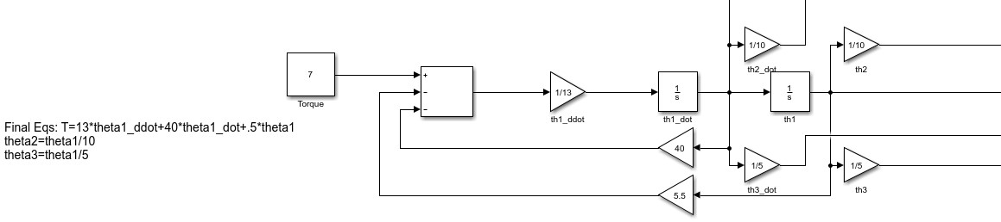

**Results:**

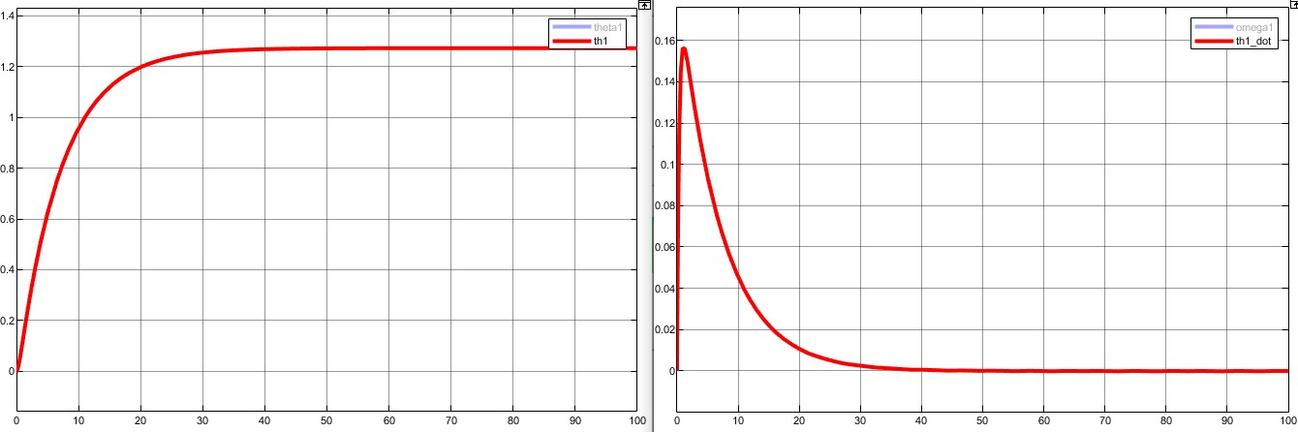

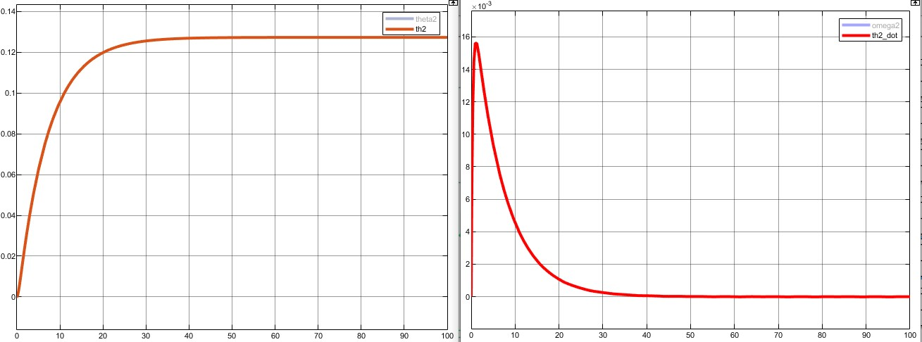

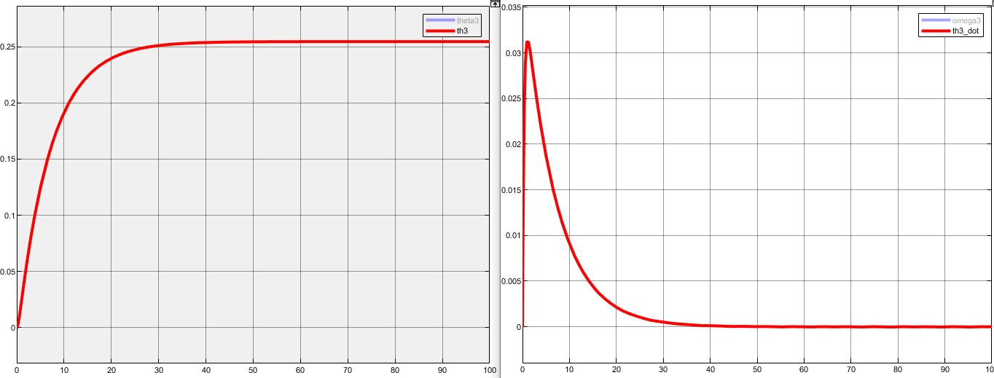

**SIMSCAPE model:**

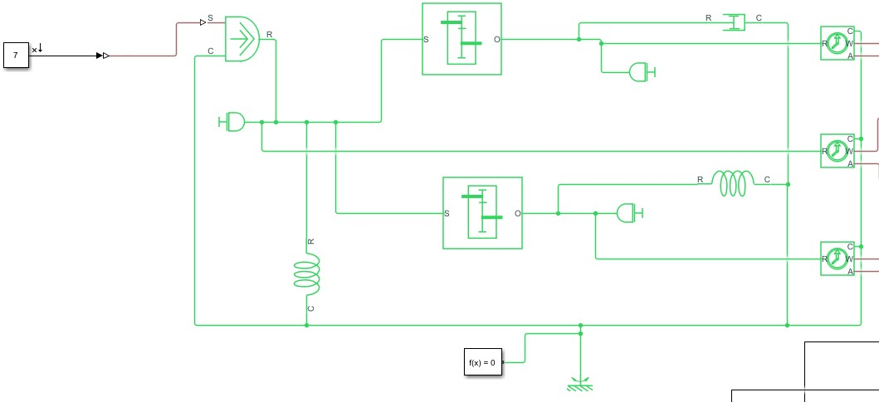

**Results:**

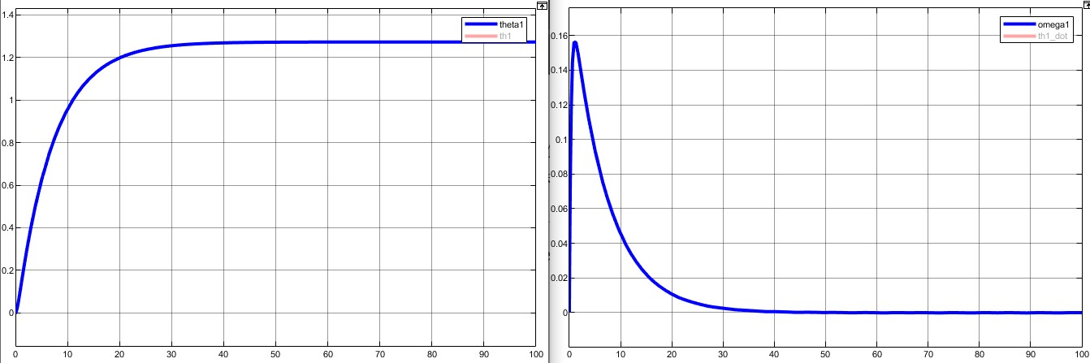

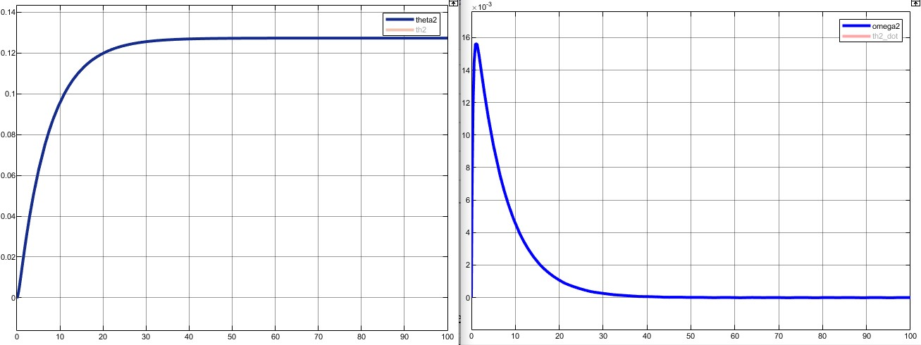

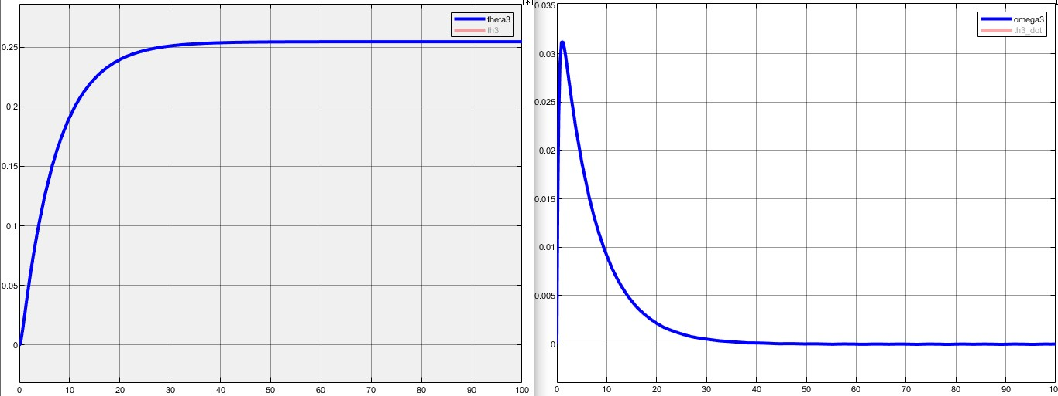

**Conclusion/Remarks:**

The results obtained by both Simulink as well as the SIMSCAPE are exactly the same. Hence the developed SIMSCAPE model is correct and is in accordance with the mathematical model (Simulink model).

The output obtained shows the effect of stiffness and inertia on the geared system. In this case, by adding a stiffness in the rod and an inertial element, the gears no longer exhibit a linearly increasing displacement pattern rather the gears rotate for some time and then the opposing force due to inertia counter balances the applied torque causing the displacement to become zero (as is evident by the graphs).

**Transfer Function from SIMSCAPE model:**

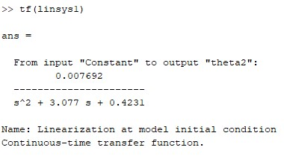

**Transfer function from m file:**

|  |
| --- |
| syms s Ttheta1=T/(13*s^2+40*s+5.5); theta2=theta1/10;  G=theta2/T;  G=collect(G,s);  [num,den]=numden(G);  num=sym2poly(num);den=sym2poly(den);  num=num/den(1); %dividing by den(1) means dividing by the leading coefficient of denominator. Done to match the outputsden=den/den(1); |

fprintf('Theta2(s)/T(s):') tf(num,den)

Following is the output:

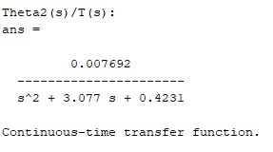

**Assigned Tasks:**

**Model 1:**

**Develop a SIMSCAPE model of the given system. The transfer function should be between** **4 and**

**Applied Torque T(t). You are required to cross-validate the outcomes with the Simulink of this model.**

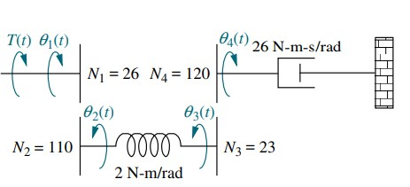

**Simulink model:**

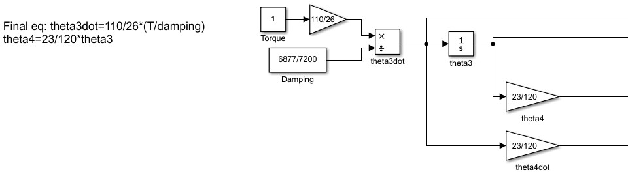

**Results:**

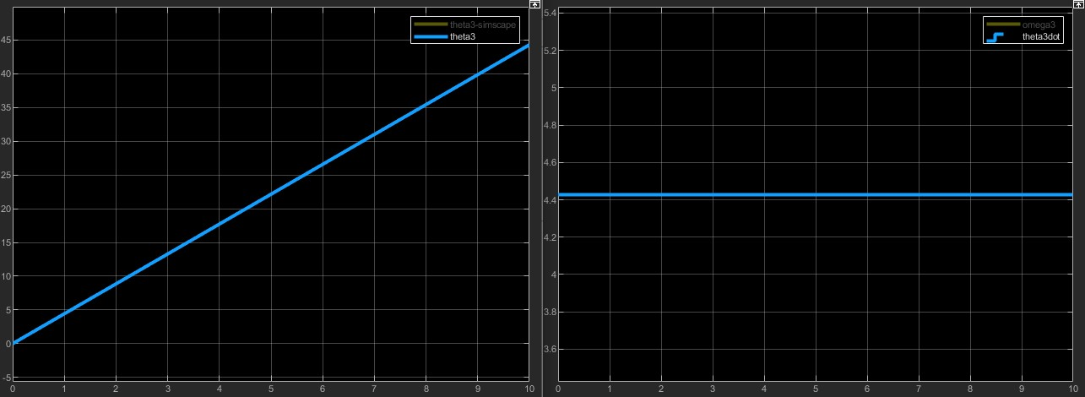

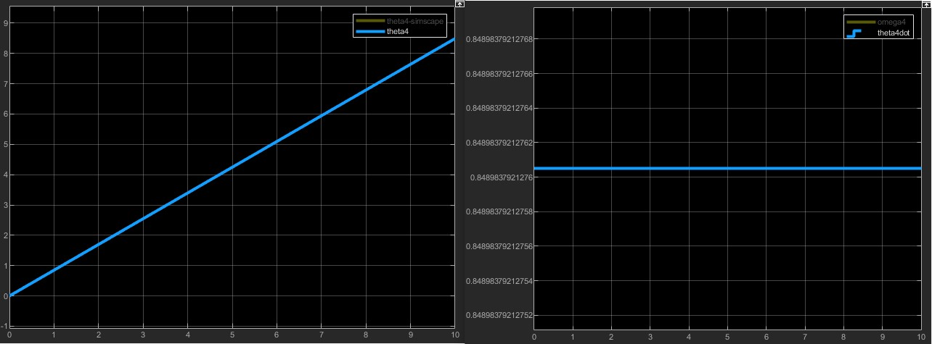

**SIMSCAPE model:**

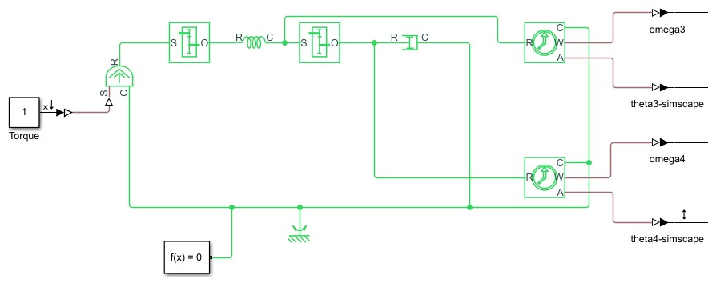

**Results:**

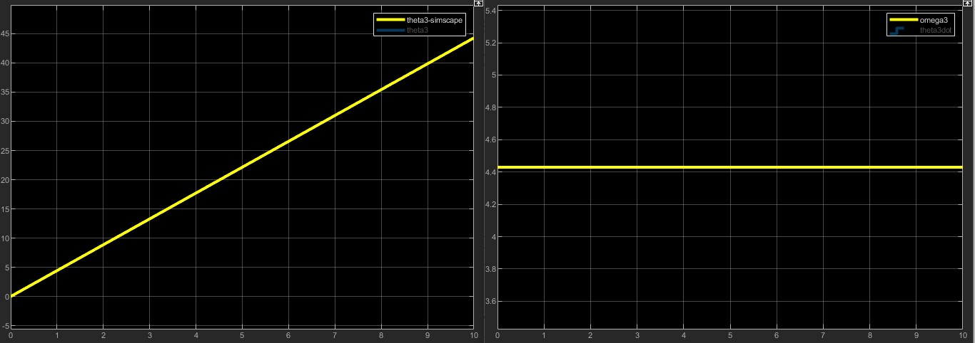

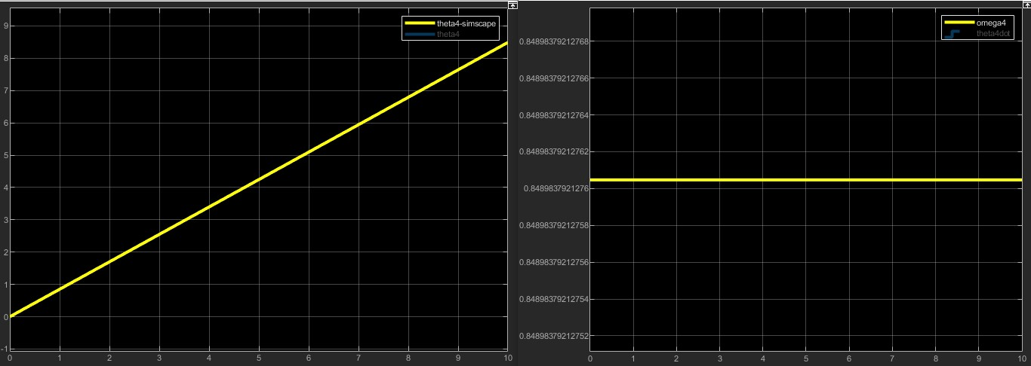

**Conclusion/Remarks:**

The results obtained by both Simulink as well as the SIMSCAPE are exactly the same. Hence the developed SIMSCAPE model is correct and is in accordance with the mathematical model (Simulink model).

The graphs obtained are logical as well; the rotational output is measured across the gear which ideally rotates continuously maintaining a constant angular velocity (by the law of gearing). This phenomenon is also observed in the plots above which exhibit a linearly increasing trend for angular displacement and a constant trend for angular velocity.

**Transfer Function from SIMSCAPE model:**

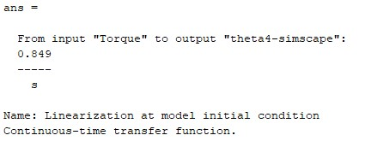

**Transfer function from m file:**

|  |
| --- |
| syms s Tk=2;d=6877/7200;  A=[k , -k ; -k , (d*s+k)];  B=[110/26*T;0];  C=A\B;  theta3=C(2);  theta4=theta3*23/120;  G=theta4/T;  G=collect(G,s);  [num,den]=numden(G);  num=sym2poly(num);den=sym2poly(den);  num=num/den(1); %dividing by den(1) means dividing by the leading coefficient of denominator i.e., 20 in this case. Done to match the outputs den=den/den(1);  fprintf('theta4(s)/T(s):')  tf(num,den) |

Following is the output:

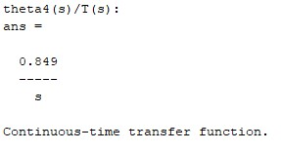

**Model 2:**

**Develop a SIMSCAPE model of the given system. The transfer function should be between** 𝑋**(**𝑡**) and Applied Torque T(t). You are required to cross-validate the outcomes with the Simulink as well as the m-files of this model.**

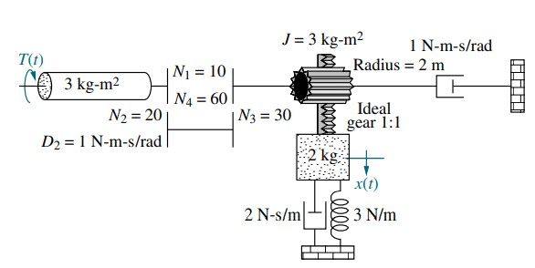

**Simulink model:**

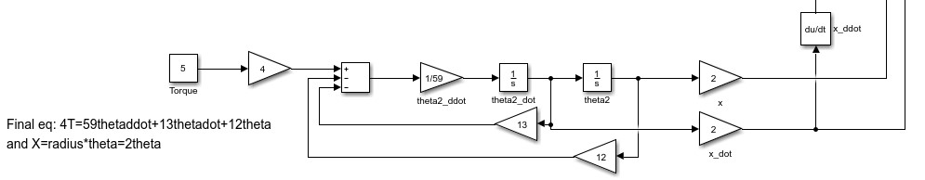

**Results:**

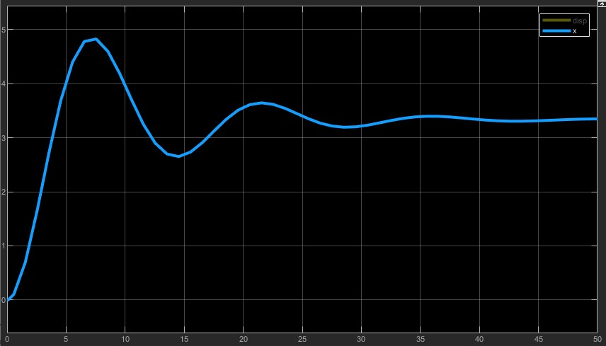

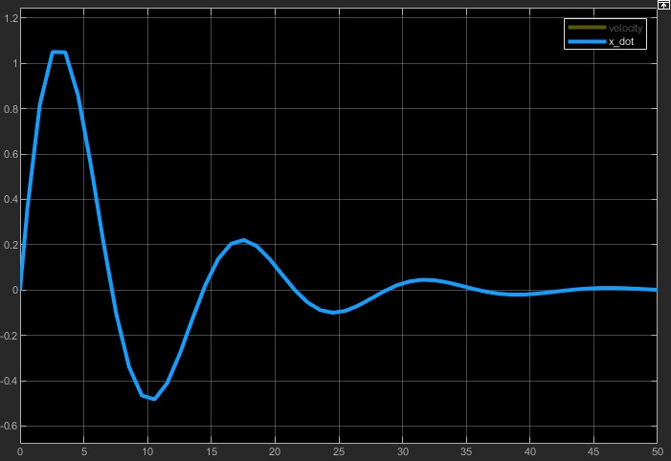

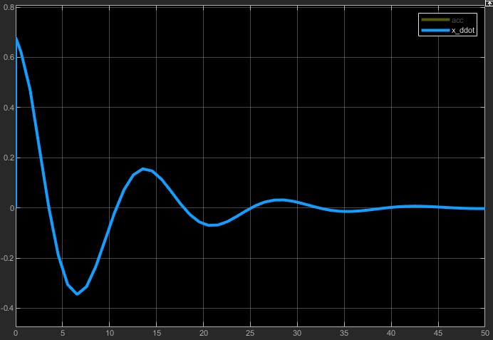

**SIMSCAPE model:**

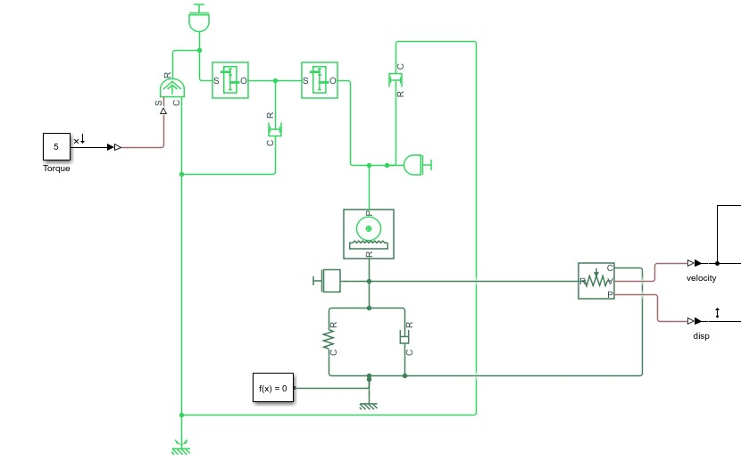

**Results:**

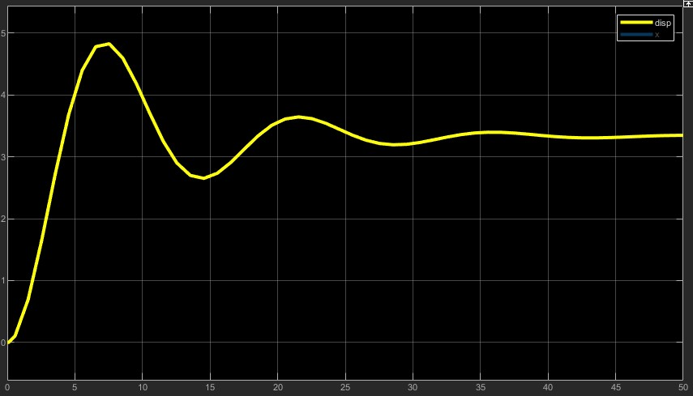

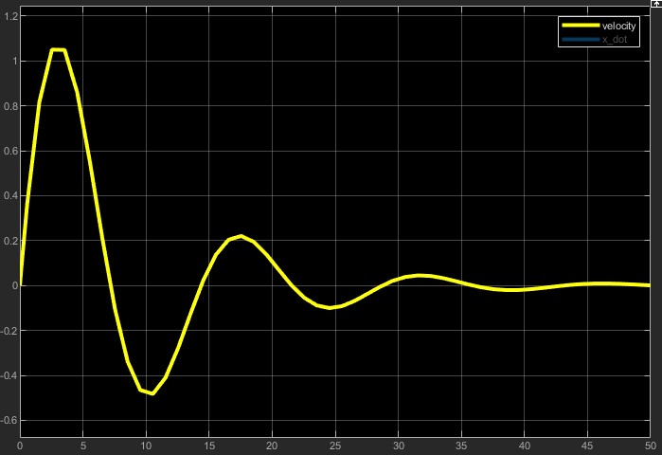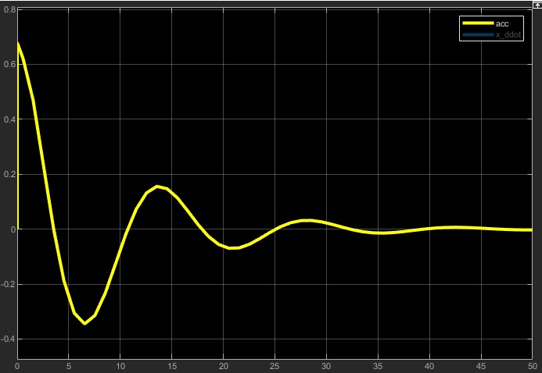

**m file result:**

|  |
| --- |
| TR=[0,10]; th0=[0;0];  [t,y]=ode45(@RackNPinion, TR, th0); theta=y(:,1); theta_dot=y(:,2); x=2*theta; x_dot=2*theta_dot;  x_ddot=gradient(x_dot)./gradient(t); subplot(1,3,1);plot(t,x);  xlabel('time');ylabel('pinion displacement'); subplot(1,3,2);plot(t,x_dot);  xlabel('time');ylabel('pinion velocity'); subplot(1,3,3);plot(t,x_ddot); xlabel('time');ylabel('pinion acceleration');  %%%%%%%%%%% function dy=RackNPinion(t,y) T=5; dy(1)=y(2);  dy(2)=1/59*(4*T -13*y(2) - 12*y(1)); dy=dy'; end |

Following is the output

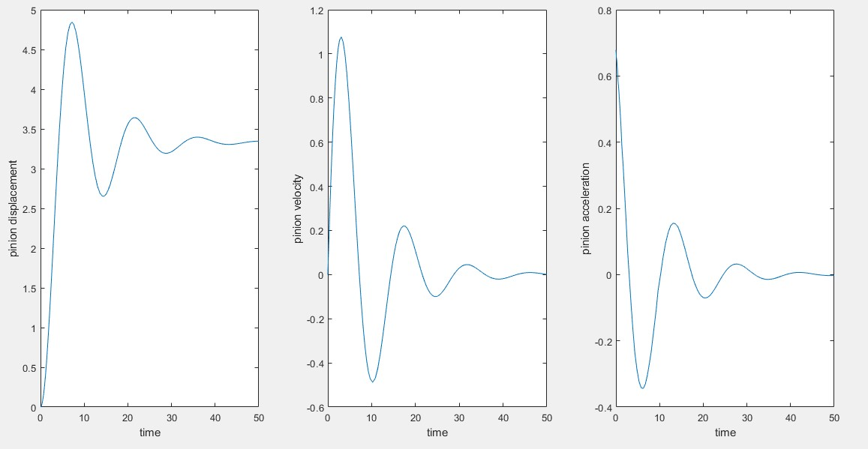

**Conclusion/Remarks:**

The results obtained by Simulink, m file as well as the SIMSCAPE are exactly the same. Hence the developed SIMSCAPE model is correct and is in accordance with the mathematical model (Simulink model).

The model has a rack and pinion which converts rotatory input to linear output hence the mass displaces from its initial position. As the displacement and velocity of the mass as well as the pinion increases the resisting forces due to the stiffness and damping also increases and after some time, they are large enough to counteract the input. Hence the system locks itself into that static position. This is evident by the plot which shows that initially the displacement, velocity and acceleration of the mass shoot to a high value and after some time the displacement becomes steady and velocity and acceleration become zero.

**Transfer Function from SIMSCAPE model:**

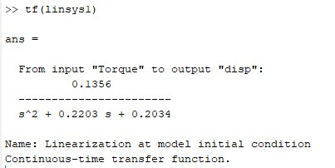

**Transfer function from m file:**

|  |
| --- |
| syms s Tradius=2;  theta=4*T/(59*s^2+13*s+12);  x=2*theta;  G=x/T;  G=collect(G,s);  [num,den]=numden(G);  num=sym2poly(num);den=sym2poly(den);  num=num/den(1); %dividing by den(1) means dividing by the leading coefficient of denominator i.e., 20 in this case. Done to match the outputs den=den/den(1);fprintf('X(s)/T(s):') tf(num,den) |

Following is the output:

